
How the App Works
A SHORT GUIDE FOR TESTING · ANDROID TEST VERSION · OCTOBER 2026

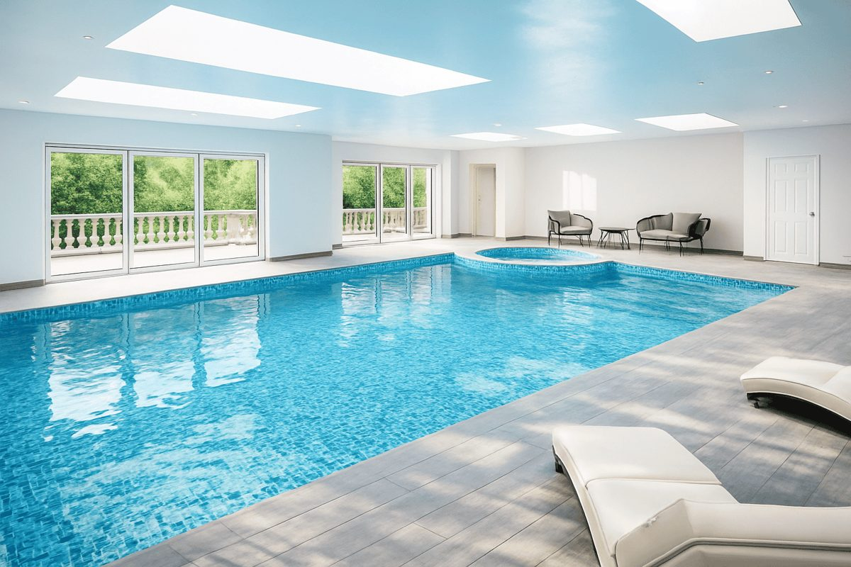  Luxury Ascot Golf & Spa Retreat  SUNNINGDALE · ASCOT | 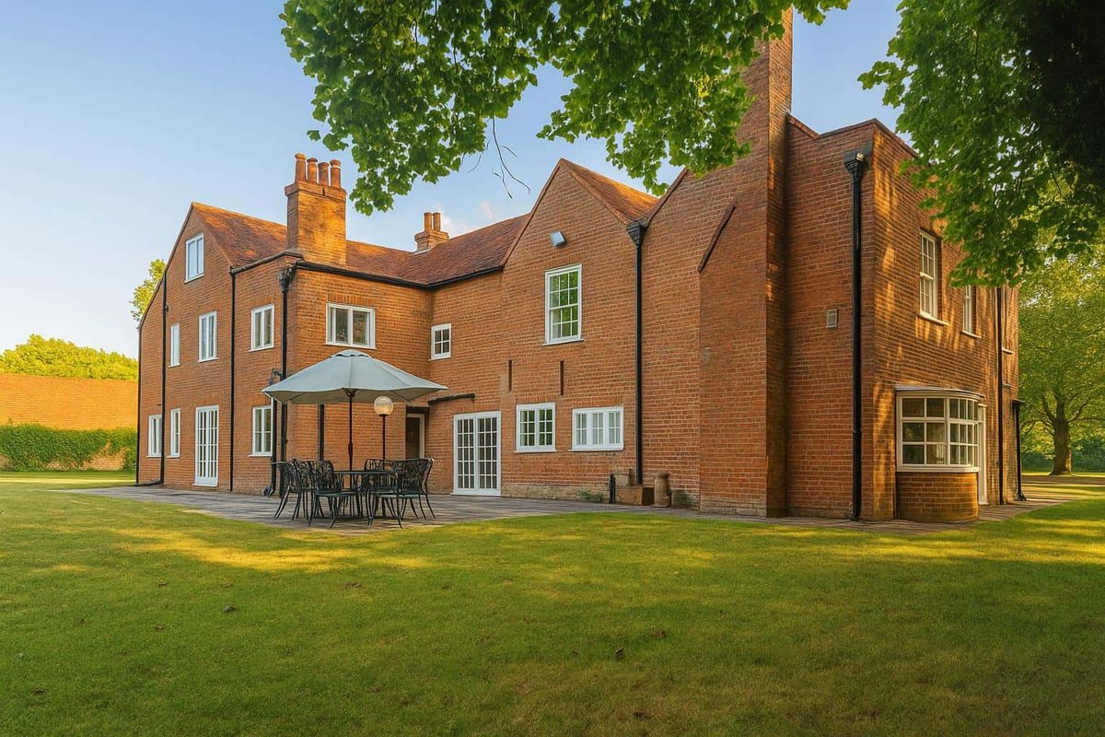  Royal Windsor Residence  WINDSOR GREAT PARK
01
Browsing
- Home shows both residences, Luxury Ascot Golf & Spa Retreat and Royal Windsor Residence, with photos, prices “from £X per night” and guest reviews.
- Tap a residence for its details, amenities and things to do nearby.
02
Booking
- Tap Check Availability and choose your dates on the calendar. Booked nights are shaded and can’t be picked.
- Choose the number of guests and pets. The full price, including fees, appears straight away.
- Tap Proceed. You’ll be asked to sign in or create an account if you haven’t already.
- On the payment screen, check your details, add a coupon if you have one, and pay by card. Your bank may ask you to confirm the payment.
- You’ll see Booking Confirmed with your booking number. The booking appears on the website’s calendar straight away.
03
Your Account
- My Bookings: your upcoming and past stays, including ones booked on the website with the same email address. Verify your email first: tap the link in the email we send at sign-up, and check spam.
- My Profile: edit your name, phone and address, and add a profile photo. Changes show up on all your devices.
- Settings: dark mode, password change, sign out, delete account.
04
Help
- Contact: phone, email, address and an enquiry form. It can be reached from the menu and from any booking screen.
- Enquiries are emailed to info@theroyalaccommodation.com, and the guest gets an automatic acknowledgement.

For This Test Version
- Payments are in test mode: no real money is taken. Use card 4242 4242 4242 4242, any future expiry date and any 3-digit CVC.
- Please book dates in December 2027. Test bookings still block those dates on the real calendar.
- If something looks wrong, send a screenshot and what you tapped.

